H₂GridTwin

A research project funded by the Energy Transition Funds of the Belgian Federal Public Service for Economy, SMEs, Self-Employed and Energy

Integration of the system components into the global digital-twin and development of the advanced control system
Deliverable D3 – October 2025

B. Avdijaj^{1,2,3}, Z. Nti^{1,3}, C. Freyling^{2,3}, L. Giuntini^{1,3}, A. Coussement^{1,3}

¹Aero-Thermo-Mechanics Laboratory, Université Libre de Bruxelles (ULB)
²Thermo and Fluid dynamics (FLOW), Vrije Universiteit Brussel (VUB)
³Brussels Institute for Thermal-fluid systems and clean Energy (BRITE), VUB and ULB

Contents
- Introduction | 1
- WP1: Electrolyser | 3
- WP2: Internal Combustion Engine (ICE) | 9
- WP3: Micro-Gas Turbine (mGT) | 14
- WP4: District Heating Network (DHN) | 16
- WP5: Optimisation of the integrated H₂ energy system | 18
- Conclusions | 22

Introduction

As the global energy transition advances toward carbon neutrality, renewable energy sources are expected to dominate the future energy mix. However, their intermittent nature, both daily and seasonal, poses significant challenges for balancing supply and demand. While short-term fluctuations can be managed using technologies such as batteries and hydraulic storage, long-term storage increasingly relies on the power-to-fuel paradigm. Among the various energy carriers, hydrogen has emerged as a promising solution due to its high energy density, versatility, and potential for integration across energy sectors. Nevertheless, hydrogen-based systems are often limited by low round-trip efficiency, primarily due to heat losses during reconversion to electricity. To improve overall system performance, integrated approaches that recover and utilize this thermal energy (particularly via district heating networks) are essential, especially in urban environments.
The H2GridTwin project aims to address these challenges through the development of a comprehensive digital twin of a hydrogen-based multi-energy system. This digital twin enables advanced control and optimization strategies, with the goal of maximizing local renewable energy use and improving energy system efficiency. At the core of the project is the creation of Physics-Informed Reduced-Order Models (PI-ROMs) for each system component, which serve as the foundation for a real-time capable, integrated digital twin.
Figure 1 provides a schematic overview of the hydrogen energy system, highlighting its main components. These include renewable energy sources, an electrolyser for hydrogen production, a hydrogen storage tank, a hydrogen internal combustion engine (ICE), and a micro–Gas Turbine (mGT) for electricity and heat generation. The system is also coupled with a district heating network (DHN) equipped with thermal storage to valorise waste heat. Batteries are included to manage short-term electricity fluctuations, while the electric grid serves as a buffer for larger energy imbalances. The architecture shown in Figure 1 reflects the overall structure of this report, which is organized according to the five work packages (WPs) of the project.

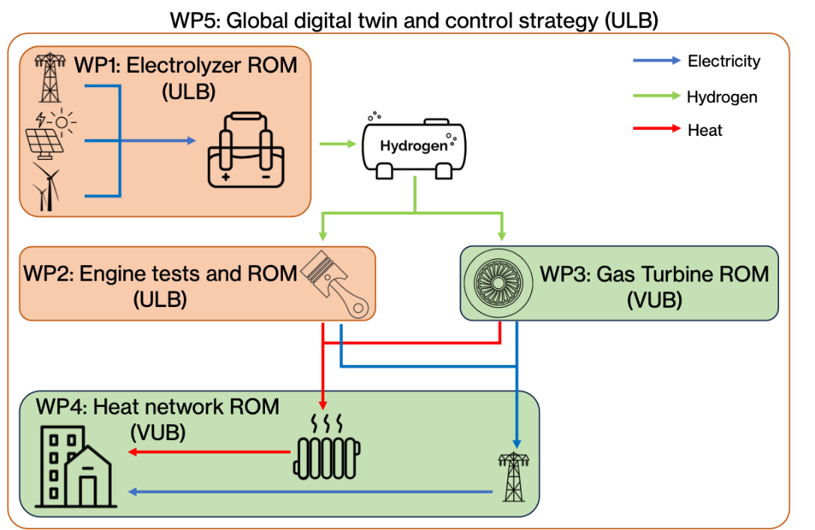

Figure 1: H₂ energy system components and associated work packages

This third deliverable (D3) builds upon the modelling approach and preliminary results presented in Deliverable 2 (D2). It presents the finalized PI-ROMs for the key components of the hydrogen energy system (WP1–WP4) and introduces the fully developed global optimization model (WP5), which integrates all component models into a single, operational digital twin. Together, these results represent a major step toward a deployable simulation and control framework for urban hydrogen energy systems.

- WP1: Electrolyser

The electrolyser is likely the most complex and key component in hydrogen systems, therefore requiring sophisticated modelling strategies to capture its behaviour. In this regard, a multi-physics model of a Proton Exchange Membrane (PEM) electrolyser was developed. The model was organized into interconnected sub-models, each capturing a different physical domain:
- Electrochemical submodel: Links the applied current to the cell voltage, from which overall power consumption is derived. The current itself is set by the hydrogen demand via Faraday’s law.
- Thermal submodel: Tracks temperature dynamics; it both affects and is affected by the electrochemical behaviour.
- Mass-transport submodel: Simulates the movement of water, hydrogen, and oxygen inside the stack, a key safety consideration because mixing H₂ and O₂ poses an explosion risk.
- Degradation submodel: Added later in the project to capture chemical membrane thinning caused by radical attack; this is crucial for evaluating the long-term economics of electrolyser ownership.
Figure 2: Schematic representation of the different physical domains and their connections inside an electrolyser
Figure 2 summarizes the full architecture. To our knowledge, none of the existing electrolyser models integrates electrochemical, thermal, mass transport, and degradation effects in a single framework; therefore, our work represents a novelty which advances the state of the art. In this regard, we submitted a scientific paper titled “Balancing Energy Efficiency and Membrane Degradation in PEM Electrolysers: A Membrane Degradation-Aware Model” to the peer-reviewed international journal International Journal of Hydrogen Energy (Cite Score 13.3; Impact Factor 8.3). Furthermore, the modelling framework developed for the degradation submodel was successfully patented, highlighting the relevance of the activities carried out in the H2GridTwin project. An overview of the white-box model was also presented at the European PhD Hydrogen Conference 2025 (Trieste, 9–11 April 2025).

  - Electrolyser model validation

The developed numerical model was compared against experimental data to assess its performance. The electrochemical submodel was validated using various experimental datasets to ensure robustness, i.e., the ability to perform well across different electrolyser types and operating conditions. The gas crossover submodel, specifically for hydrogen crossover, and the membrane degradation submodel were also calibrated and validated against experimental data available in the literature.

    - Electrochemical submodel

Experimental data from the literature (Abdin et al., 2015; Fragiacomo et al., 2019; Liso et al., 2018) were used to validate the electrochemical submodel and to test its generalizability.

a) | b) | c)
Figure 3: Comparison between the experimental polarization curves and the predicted polarization curves

Figures 3a-c show a relatively good agreement between the model and the experimental datasets. The predicted voltage values closely match the measured values, with a maximum mean absolute percentage error (MAPE) of 3.2% in the first simulated conditions (Figure 3a). The MAPE values in the other two simulated cases, reported in Figures 3b and 3c, are even lower further underlying the model accuracy.

    - Gas crossover submodel

Experimental data from Schalenbach et al. (2015) were used to calibrate the gas crossover submodel. As shown in Figure 4 the model predictions align well with the experimental results across various cathode pressures and current densities.

Figure 4: Predicted and measured hydrogen crossover at T=353 K, based on model and data from Schalenbach et al., 2015.

    - Membrane degradation submodel

To validate the degradation submodel, data from Chandesris et al. (2015) was utilized. The model developed in this work was compared to both experimental data and the model proposed in Chandesris et al. (2015) at temperatures of 333 K and 353 K. The results demonstrate that the present model outperforms the previous one, as reflected by the MAPE values shown in Figures 5a and 5b. This improvement is particularly notable at 333 K, where the MAPE is four times lower. The discrepancy is most pronounced at very low current densities (below 0.4 A\cm²), where the model from Chandesris et al. (2015) significantly overestimates emissions, as depicted in Figure 5a. At 353 K, the present model also shows greater accuracy, particularly at medium and high current densities (i=0.4 and i=1 A\cm²), as highlighted in Figure 5b. Overall, the current model represents a significant improvement over the previous one, primarily due to incorporating temperature-dependent reaction rates, which enhance its predictive capability across different temperatures.

a) | b)
Figure 5: Measured Chandesris et al. (2015) and predicted fluoride emission rates according to the present model and model of Chandesris et al. (2015)

  - Preparing the electrolyser model for the control algorithm

While the developed model showed enhanced predictive capabilities in terms of accuracy, it also exhibited numerical stiffness, making it unsuitable for control purposes. This issue was mainly due to the degradation submodel, which required time steps on the order of milliseconds, incompatible with control horizons spanning hours, days, or weeks. To resolve this issue, we replaced the physics-based degradation block with a data-driven surrogate. Steady-state data from the original sub-model were used to train a neural network optimised via Bayesian regularisation.

Figure 6: Degradation rates predicted by the white-box model (blue) and the neural-network model (red)
When tested under previously unseen operating conditions, the network reproduced the degradation behaviour of the original physics-based model with excellent fidelity, as shown in Figure 6. By replacing the original degradation sub-model with the neural-network surrogate, we obtained a reduced-order model of the electrolyser that permitted much larger time steps. The new formulation eliminated numerical stiffness, enabling efficient long-horizon optimisation and control.

  - An optimal control strategy for the electrolyser operation

To optimize the electrolyser operation, we investigated the effect of temperature, being one of the most influential parameters on electrolyser performance and lifetime. In particular, high temperatures lead to high energy efficiency but degrade the membrane quicker. On the other hand, low temperatures decrease the efficiency but slow down the degradation of the membrane and consequently increase the lifetime of the electrolyser. Our aim was therefore to identify the optimal operating temperature that minimises the total cost, i.e., the sum of electricity consumption and degradation‐related replacement costs, under realistic electrolyser and power-price scenarios.

A control algorithm was selected to achieve this optimization, which represents a first step in the definition of a control strategy for the global digital twin of the full hydrogen energy system. After a literature review, Model Predictive Control (MPC) was considered the most pertinent framework for the scope. This algorithm takes control actions (e.g., electric current applied, cooling water flow rate, etc) to minimize a cost function over a finite horizon. This method allows anticipating future events (e.g., energy price variations, weather conditions, etc) and taking control actions accordingly.
Furthermore, MPC allows handling constraints on inputs, outputs, and states, which is ideal to maintain the system within physical and process boundaries. All these advantages make MPC a perfect candidate for the control algorithm, not only for the electrolyser but for the whole hydrogen system. The main disadvantage is that it can get computationally expensive for long control horizons, as the number of variables increases. This highlights the need for a low-order, accurate digital twin of the global system.

A case study was simulated in which the electrolyser needs to produce a certain amount of hydrogen in six hours, considering different price scenarios. We considered three possible electricity prices: 50, 100, and 150 €/MWh, and two electrolyser stack prices: 400 and 1000 €/kW.
Figure 7 displays expected trends:
- Lower electricity prices reduce the value of efficiency. When power is cheap, the optimiser prioritises membrane longevity over electrical efficiency, selecting a cooler operating temperature to slow down degradation.
- Higher stack costs call for greater protection. For the same electricity tariff, the optimal temperature is at least 5 °C lower when the electrolyser stack is more expensive (Figure 7b vs Figure 7a), reflecting the higher penalty associated with accelerated ageing.
a) | b)
Figure 7: Optimal electrolyser operating temperature for different electricity prices (50, 100 and 150 €/MWh) for: a) cheap electrolyser stack (400 €/kW) and b) expensive electrolyser stack (1000 €/kW).

To further demonstrate the robustness of the MPC control algorithm, we challenged the grey‑box electrolyser model with a 24‑hour electricity‑price profile featuring frequent, irregular fluctuations (as shown in Figure 8). The simulation was carried out with a time resolution of 15 minutes, resulting in 96 discrete time steps over the full horizon. Results, presented in Figure 8, are obtained in approximately 5 minutes on a standard consumer-grade computing system (MacBook Pro, Apple M2 Pro). This demonstrates the computational efficiency of the MPC and its potential applicability in real-time implementation.

a) | b)
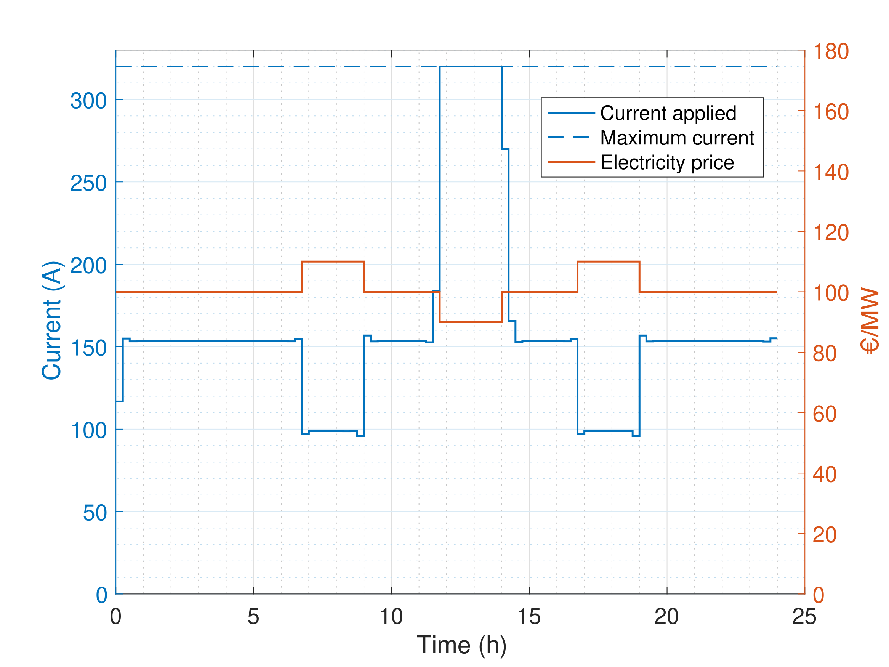 | 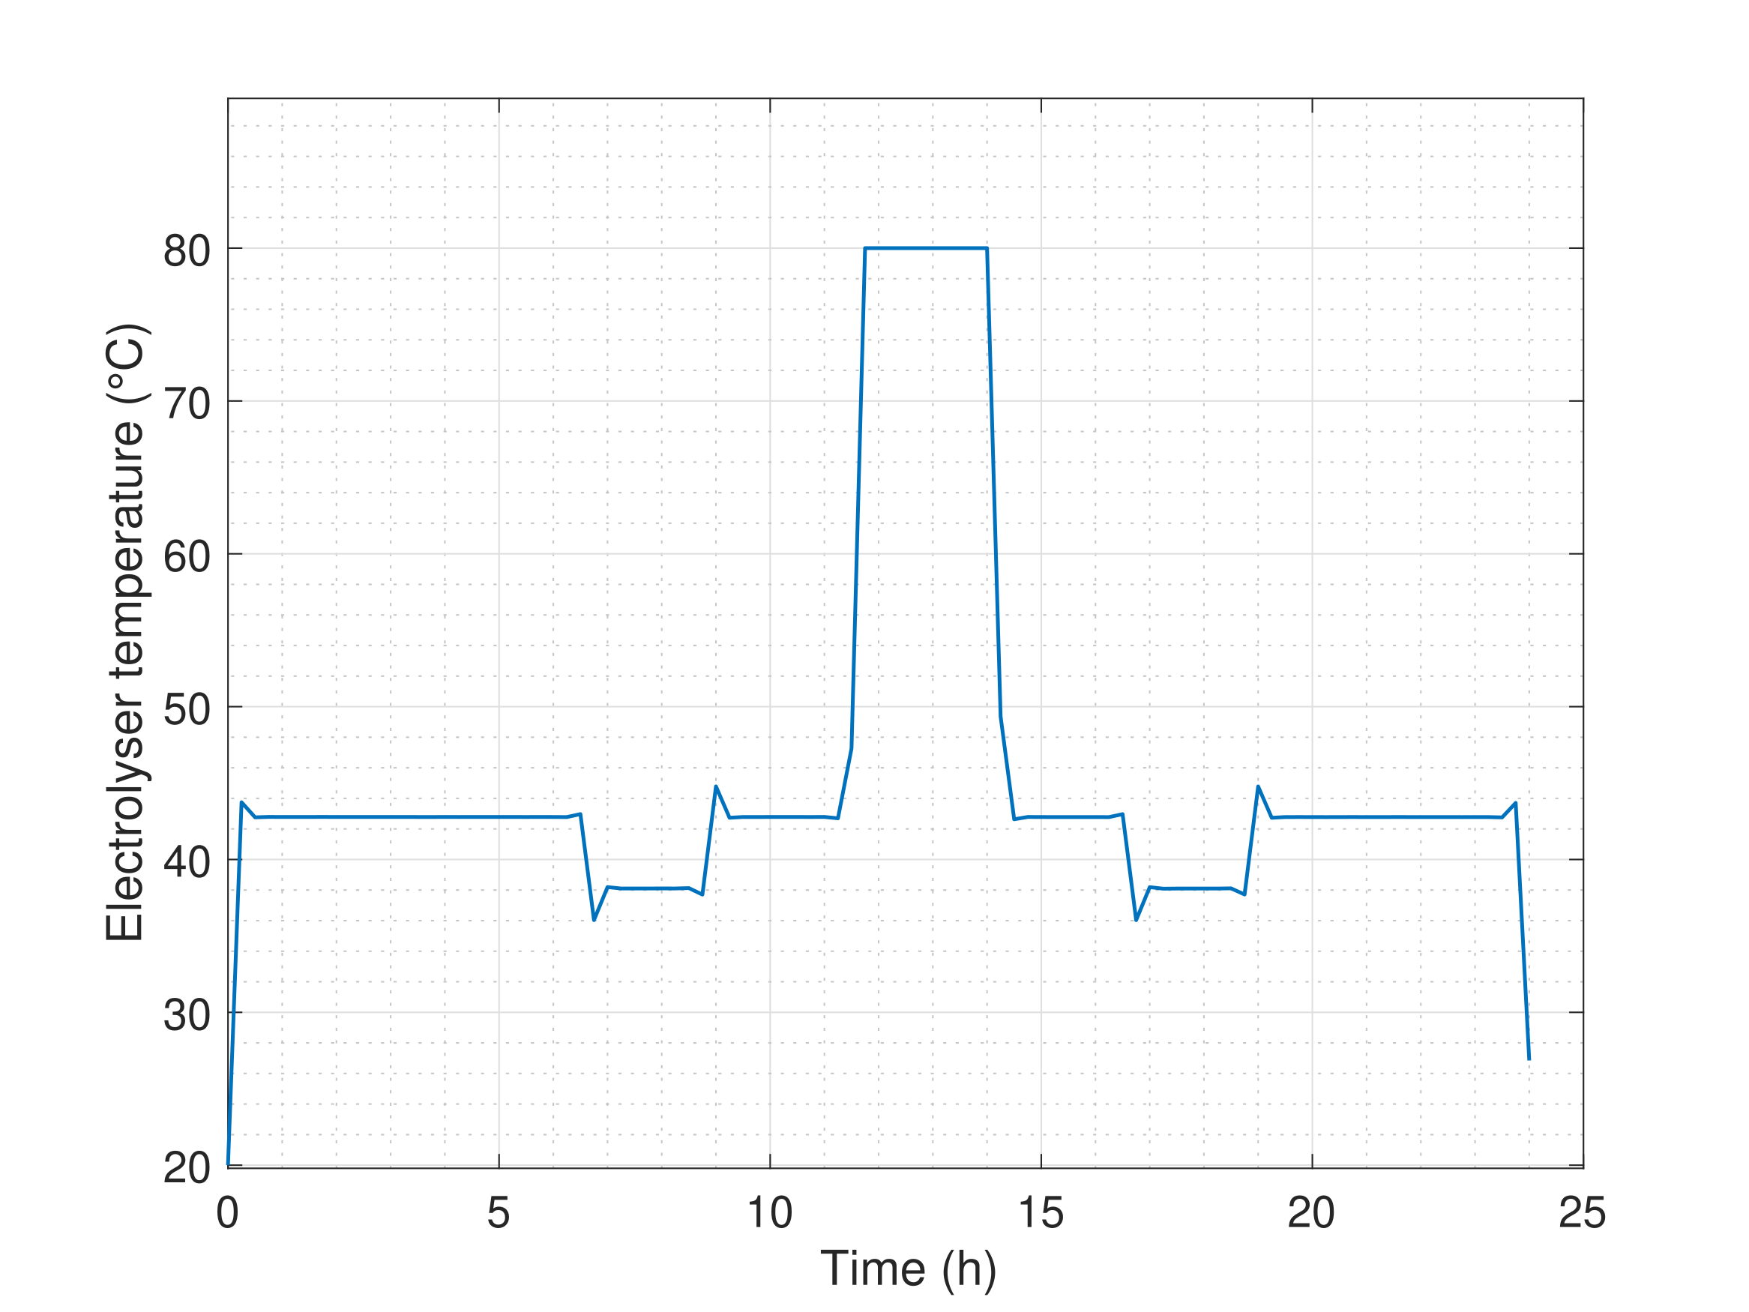
Figure 8: Variable electricity price and optimal current (plot a) with associated optimal temperature (plot b).

The simulation results show a clear dependency between the applied current and the electricity price. Specifically, higher current densities are scheduled during low-price intervals, while lower current densities are selected when electricity prices peak. This behaviour reflects the expected demand-response capability of the controller (see Figure 8a). The evolution of the electrolyser temperature profile over time (see Figure 8b) exhibits non-trivial transitions that highlight the method’s ability to balance energy efficiency, degradation costs, and temperature dynamics. Such control patterns would be difficult to derive manually or through rule-based strategies, thereby underscoring the benefits of a predictive approach, which can maintain the hydrogen production target over a 24-hour period despite dynamically changing external conditions.
In conclusion, these case studies confirmed that the MPC can efficiently deal with multiple constraints and data streams, validating its role as the core algorithm for the global digital-twin optimization.

- WP2: Internal Combustion Engine (ICE)

This work package focuses on modelling a hydrogen internal combustion engine and analysing the impact of various operational parameters on its electric and thermal efficiency. As illustrated in Figure 9, the model is structured around a four-stroke cycle engine.
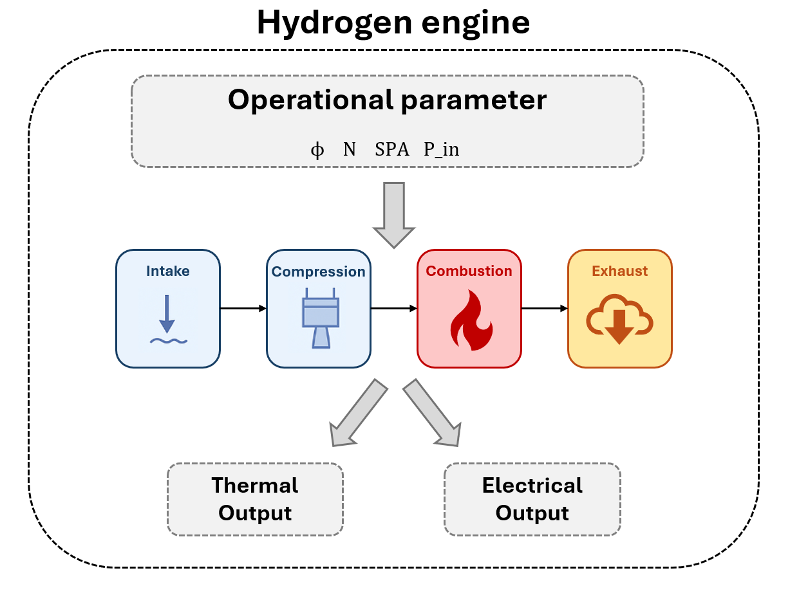
Figure 9: Schematic representation of the goal of this work package

As shown in Figure 10, a two-zone model was chosen to represent the engine operation. While other approaches exist, single-zone models were deemed too simplistic and multi-zone models too computationally expensive for the intended scope, making the two-zone model the ideal compromise for integration into the global digital twin.

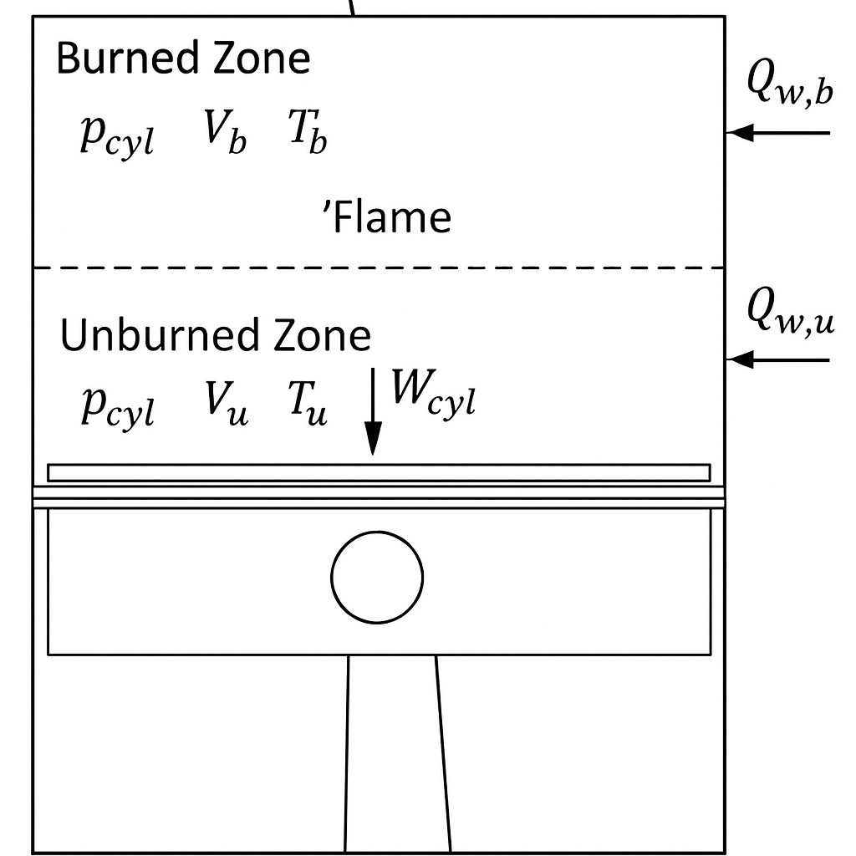
Figure 10: Schematic representation of the 2-zone 0D model of the hydrogen ICE
  - ICE model validation

For model validation, the datasheet of the Agenitor 404c engine from 2G Energy was used, as this is the engine intended for implementation in the global hydrogen system. From the datasheet, all necessary input parameters (such as engine load, compression ratio, and operating conditions) were extracted and integrated into the model. The only missing data were the combustion parameters, which are essential because they determine how rapidly the air–fuel mixture burns and define the resulting heat release rate. However, the datasheet provides electrical power output and heat generation at three different load conditions. Using this information together with the Wiebe function (an empirical equation describing the burned mass fraction x_{b}​ as a function of crank angle θ) we were able to calibrate the combustion process. The Wiebe equation is expressed as:

$$x_{b}=1-\exp\left[-a{\left(\frac{θ-θ_{0}}{Δθ}\right)}^{m+1}\right]$$

where the parameters a, m, and Δθ define the shape, efficiency, and duration of the combustion process, respectively. The Wiebe function starts at x_{b}=0 (unburned mixture) and follows an S-shaped curve that reaches x_{b}=1 at complete combustion. This provides a realistic description of combustion progression, from ignition to completion, as a function of crank angle.
By tuning these parameters, the model was calibrated to reproduce the engine’s performance under the three load cases, thereby validating the 0D simulation model. Table 1 compares the model predictions with the manufacturer’s experimental data at full load.

Table 1: Comparison of model results with manufacturer data at full load.
Parameter | Manufacturer data | Model | Relative error
Energy input [kW] | 304 | 304 | 0%
Electric power [kW] | 115 | 116 | 1%
Recoverable thermal output [kW] | 128 | 127 | 1%
Air mass flow [kg\h] | 950 | 950 | 0%
Exhaust gas temperature [°C] | 325 | 328 | 1%
The close agreement between simulated and measured values validates the modelling approach and demonstrates that the simplified two-zone configuration achieves a good balance between accuracy and computational efficiency, making it suitable for integration into the MPC framework of the global digital twin.

  - Need for a predictive ICE model
While the current model performs well at the calibrated operating points, it has limited predictive capability when conditions change. In this regard, a crucial parameter in hydrogen engines is the spark advance: by adjusting the ignition timing, the balance between electrical power and recoverable heat can be tuned according to demand.
However, the current model is not capable of predicting engine behaviour as a function of spark advance, since it was calibrated only at the manufacturer’s specified operating conditions. As a result, it cannot reliably capture how changes in ignition timing influence the combustion process and overall engine performance. To overcome this limitation and extend the model’s predictive capability, a more physically consistent and data-driven combustion model is required. The next section presents this model extension, developed using symbolic regression techniques.

  - ICE model extension via symbolic regression

As explained in the previous section, the combustion process was modelled using the Wiebe equation, with parameters tuned to match the experimental data provided in the engine datasheet. However, this calibration-based approach limits the model’s predictive capability, especially when operating conditions deviate from the range in which the model was trained.

For gasoline engines, developing a predictive combustion model is relatively straightforward because turbulent flame speed has been extensively studied, and reliable correlations exist for various engine geometries and configurations. In contrast, for hydrogen-fuelled engines, such correlations are far less generalizable. The laminar and turbulent flame velocities depend strongly on engine design and operating conditions, making it difficult to transfer existing models across different configurations.
To address this limitation, machine learning techniques were introduced to develop a predictive combustion model capable of estimating the combustion process as a function of key operational parameters. This approach allows the model to adapt to varying conditions and provide more accurate results without relying solely on empirical fitting.

While many machine learning methods exist, the goal of this project was not to create a black-box model but rather to combine thermodynamic principles with data-driven techniques in an interpretable framework. For this purpose, symbolic regression was selected. This method identifies explicit mathematical relationships between input and output variables. It begins by generating a population of candidate equations, then iteratively applies mathematical operations and evaluates their performance on the dataset. Through this evolutionary process, the algorithm converges toward a transparent and interpretable equation that best represents the data. The resulting expression can then be implemented directly into the combustion model without significantly increasing computational cost.

In this project, the key challenge lay in the Wiebe function parameters (a, m, and Δθ) which previously required manual tuning. Using symbolic regression, explicit relationships were derived for these parameters as functions of critical operating variables such as equivalence ratio, engine speed, compression ratio, and intake pressure. These inputs were selected based on literature findings as the most influential factors governing hydrogen combustion.

Experimental data from several hydrogen engines were collected and used to train and test the algorithm, with 80% of the data for training and 20% for testing. As reported in Figure 11, the resulting equations demonstrated strong predictive accuracy, showing that the model can reliably estimate combustion behaviour across a wide range of operating conditions.

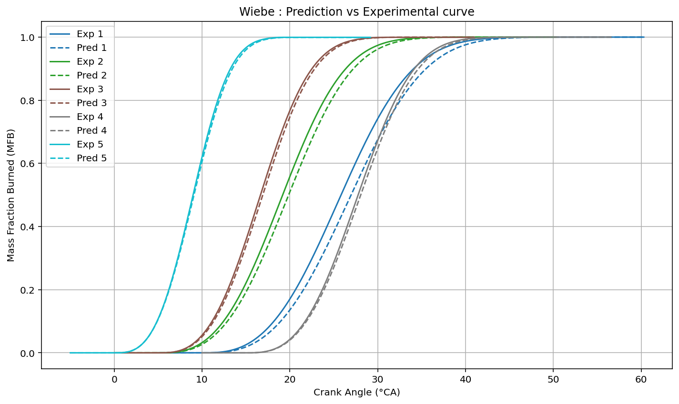
Figure 11: Testing the symbolic regression-based model of the hydrogen ICE against experimental data

Once the symbolic equations were obtained, they were tested on an independent engine for which separate experimental data were available. As shown in Figure 12, the model successfully reproduced the combustion behaviour of an engine with a completely different configuration. This demonstrates that the derived symbolic equations generalize well and effectively capture the underlying physics of the hydrogen combustion process, including that of the Agenitor 404c engine.
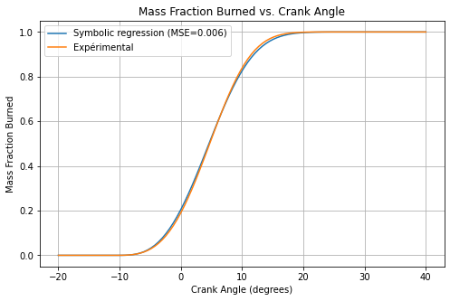
Figure 12: Mass fraction burned prediction against experimental

With the implementation of the symbolic regression-based combustion model, the overall engine model becomes more predictive and physically consistent. It can now accurately capture the effects of spark timing variations, such as advancing or retarding the ignition, as illustrated in the Figure 13.

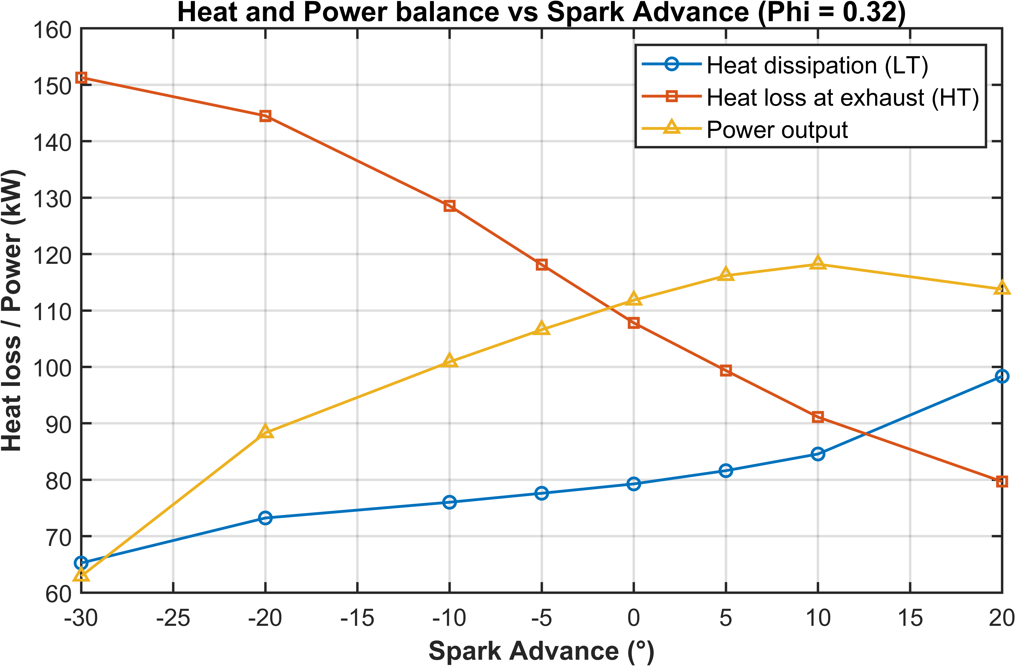
Figure 13: Predicted heat and power generated by the Agenitor 404c engine for varying spark advance.

We were also able to predict variations in the equivalence ratio thanks to the symbolic regression model, as presented in Figure 14.

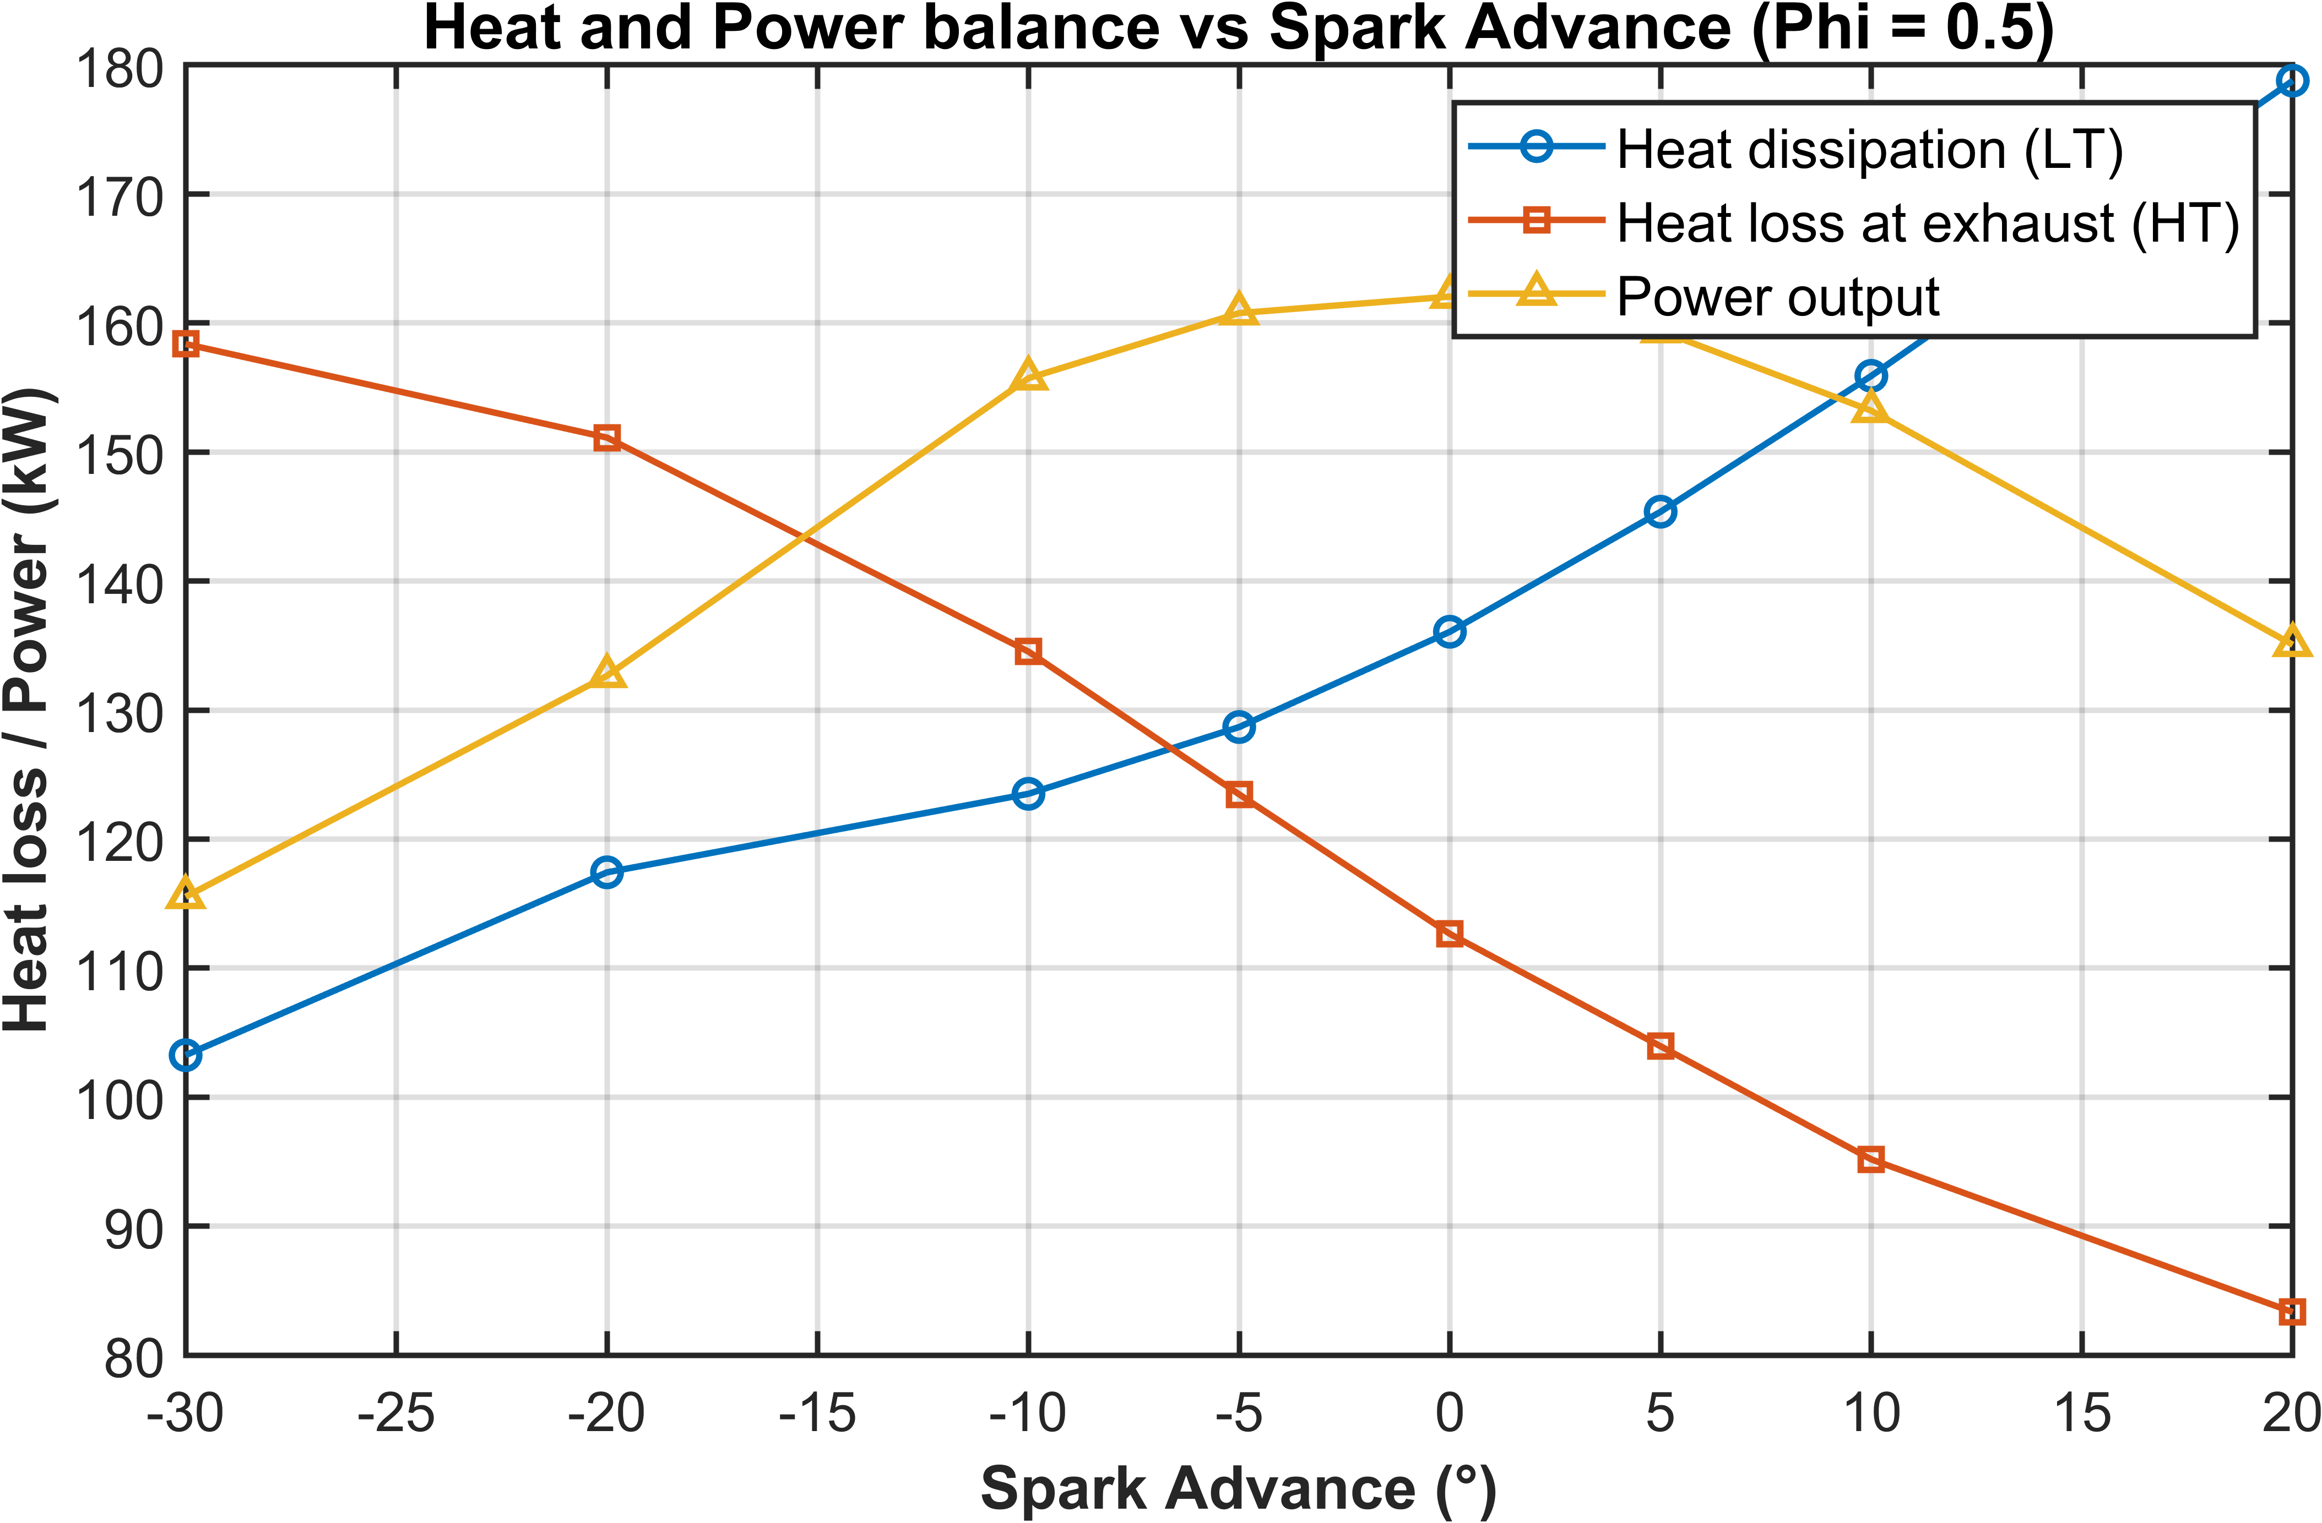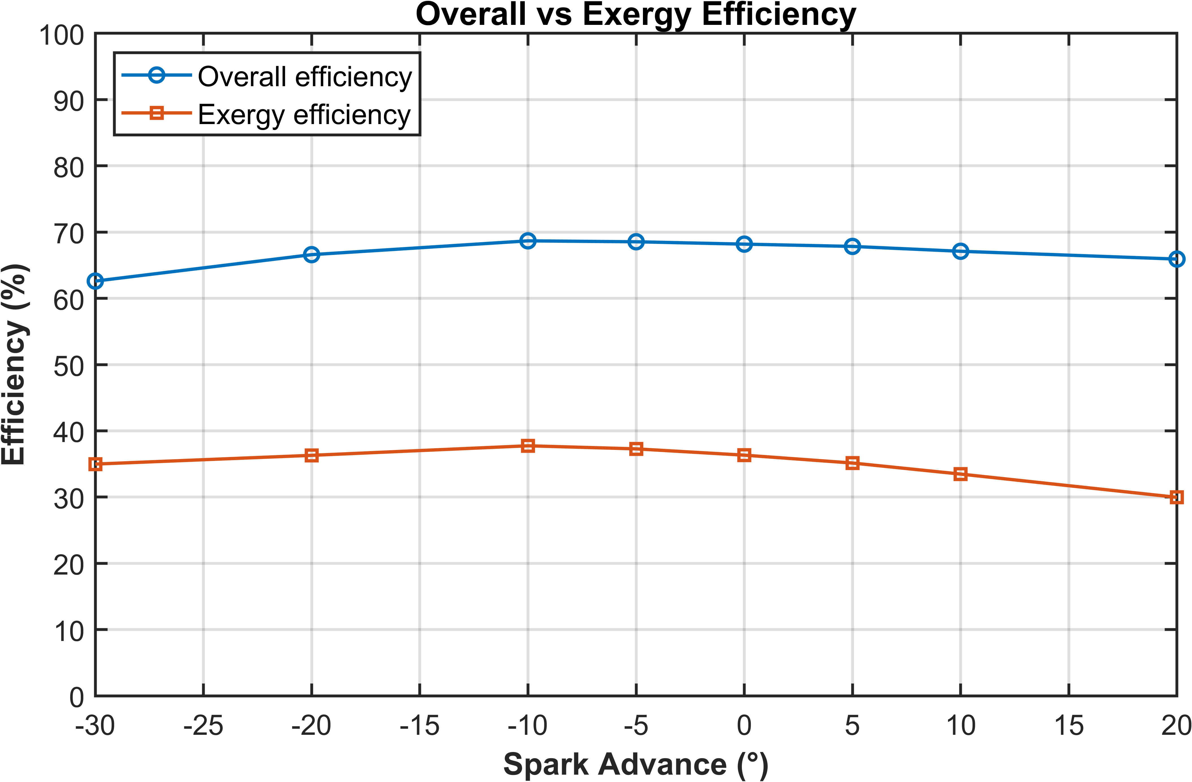
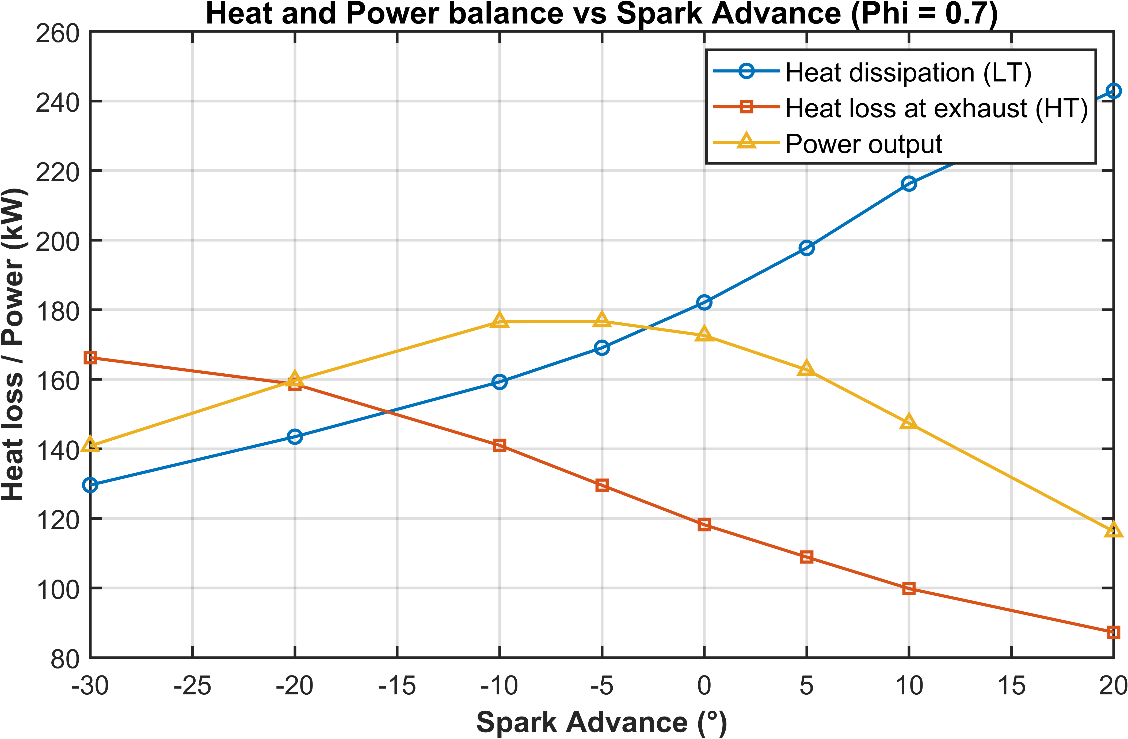
Figure 14: Predicted heat and power generated by the Agenitor 404c engine for varying equivalence ratio

- WP3: micro-Gas Turbine (mGT)

The modelled micro gas turbine is the single-shaft Turbec T100 with 100kW nominal electric power, introduced in the previous deliverables. It has a rated electrical efficiency of 30% and can be used as a combined heat and power (CHP) system, using the exhaust heat of the flue gases to heat water. It can operate in half load with stable operation as of 50 kWe. The micro gas turbine is characterised by a very fast reactivity, able to change its load within 10 to 20 seconds, although the heat recovery system has more inertia. The start-up and shutdown procedures both last 5 to 10 minutes. The starting point of this mGT model was a validated dynamic model developed by UMons and implemented in MATLAB Simulink with each mGT component being represented as interconnected 0D blocks and a 1D block for the recuperator. This model showed high accuracy, both in steady state and transient simulation, but it was computationally expensive making it unsuitable for implementation within the advanced control framework of the global digital twin of the hydrogen living lab. However, the dynamic model of the mGT represented a good basis to develop a reduced-order model with the required simplifications to reduce its computational time. The dynamic model clearly shows the fast load changing abilities of the mGT (see Figure 15), justifying the use of a quasi-static mGT model instead. Even more so because the global digital twin will not be able to optimize its performance every few seconds, the time horizon will rather be in the order of magnitude of several minutes. The start-up and shutdown phases of the mGT can be modelled by following a conservative approach, such as considering fuel consumption with no power or heat production. This will also prevent the frequent start-up and shutdown of the mGT by the control system of the complete digital twin.
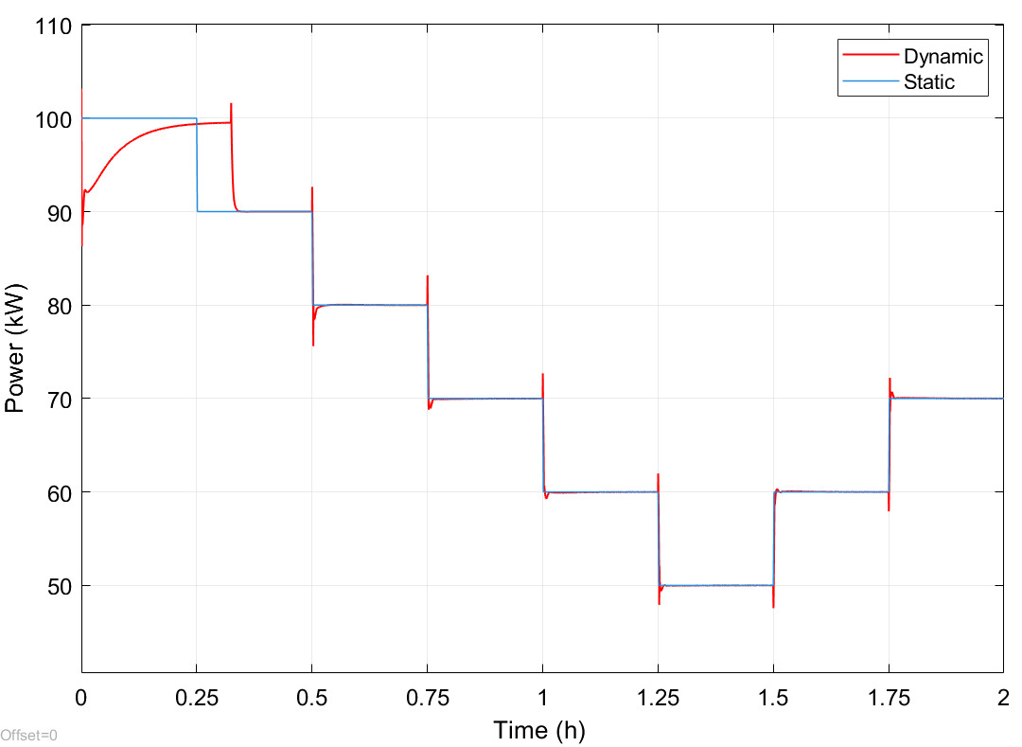
Figure 15: A comparison of the dynamic and static model, showing the fast dynamics of the micro gas turbine.

The static mGT model based on the Turbec T100 was then developed and validated. From the control algorithm view-point, it is crucial that the mGT model provides accurate results both for design and off-design operation as the mGT might often be requested to operate in partial load. Each component of the mGT was modelled using thermodynamic relations and turbomachinery maps. The thermodynamic model was also improved to increase the computational speed, though introducing approximations which slightly affected accuracy. In this regards, the use of the NASA polynomials was chosen to determine the fluid properties over the slightly more accurate CoolProp Library (see Figure 16). Even though CoolProp is on average 0.5% more accurate, it is more than 10 times slower than the NASA polynomials. This is due to the external action that is needed to call CoolProp each time the mGT model is used.
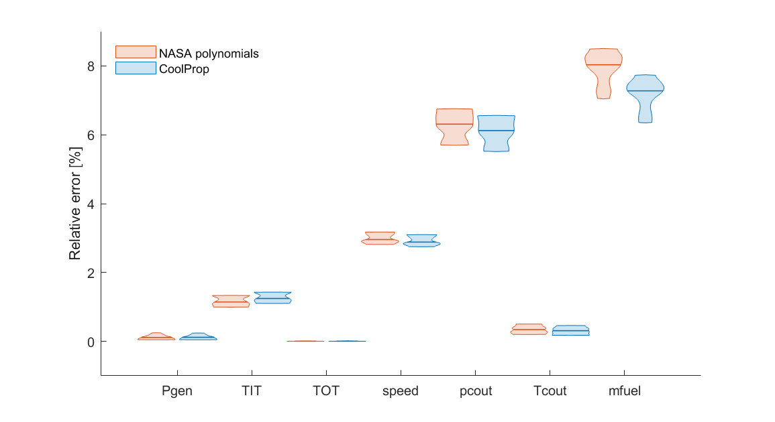
Figure 16: Violin plot of the comparison of the median errors of the parameters using NASA polynomials or the CoolProp Library, bounded by the 1st and 3rd quartile.

This general static mGT model still has deviations between the model results and experimental data. These residual errors remain due to the assumptions made. Some values, such as heat losses and component efficiencies are approximated from literature. Each experimental setup is also different, with slightly different tolerances or mismatches with the general turbomachinery maps obtained. Even if the turbomachinery maps are available from the manufacturer which is the case for the T100, these are often validated using limited experimental datapoints and scaled accordingly. For better results, it is interesting to use an experimental dataset to further tune the general static model and reduce the errors with the model results even more. This is done by tuning those uncertain variables and scaling the turbomachinery maps. These parameters are optimized by minimizing an objective function using constrained multivariable nonlinear optimization methods. The optimization is done offline and then these optimized parameters are integrated into the mGT model. When maintenance is done and substantial changes are made to the mGT setup, this process can be repeated. This ensures that the results of the digital twin of the mGT remain as close as possible to the experimental setup.
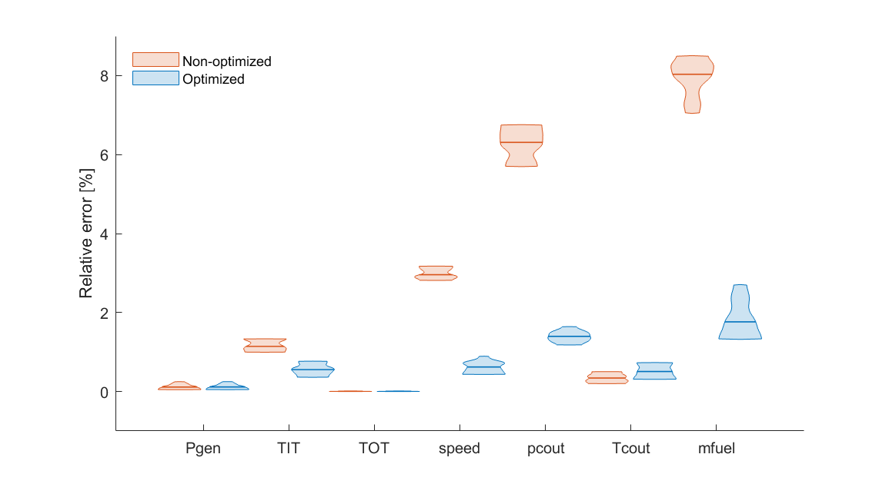
Figure 17: Violin plot of the comparison of the median errors using the original or optimized parameters, bounded by the 1st and 3rd quartile.

The optimized mGT model shows reduced errors compared to the initial model, demonstrating the importance of this optimization technique (see Figure 17). The relative error of the generated power (P_{gen}) and turbine outlet temperature (TOT) remain equal, but they were already accurately predicted with average errors below 0.5%. The average error on the compressor outlet temperature (T_{c,out}) slightly increases with optimization but still remaining below 1%. On the other hand, the errors on the fuel flow rate (m_{fuel}), compressor outlet pressure (p_{c,out}) and rotational speed decrease substantially with optimization, from above 8%, 6% and 3% to below 1-2% error, respectively.

WP4: District Heating Network (DHN)

A District Heating Network (DHN) model was developed consisting of multiple heat sources, the heating network, a thermal storage, and the connected buildings' heat demand that must be satisfied. The heat demands will be provided as inputs to the ROM based on day-ahead forecasts. The heat sources are set to be the mGT and the ICE heat recovery systems.
The heat network model involves solving for both the pressure and temperature of water along the network, considering losses along the pipes and at the substations. The pressure model determines the required electrical power for pumps, and the thermal model ensures the heat demand is satisfied, while also taking into account the heat losses towards the ambient. For the hydraulic part, a steady-state model is used, because the hydraulic transients (i.e., pressure perturbations) are often several orders of magnitude faster than thermal transients. However, for the thermal part, a dynamic model is needed, also because the thermal inertia of the heat network itself, i.e. the water inside the network pipes, can serve as a thermal storage.
A one-dimensional finite-volume method is used to describe the heat network dynamics. This method consists of dividing the pipes into different sections and applying an energy balance to them. As it is shown in Figure 18 below, this approach makes sense as the time constant of a pipe of 100 meters is non-negligible in a 15-minute framework, which is the integration time-step that will be used in the control algorithm of the global digital twin. This to say that, for instance, the ULB campus has a 1.4 km-long heat network pipeline while the the VUB campus one is 1.5 km-long.
Figure 18: Temperature profile in a supply pipe, in different locations, with a temperature of the feed water = 353 K

This also has an impact on the power consumption, as, at the beginning, the water temperature in the supply pipes is lower and thus, the flow rate must be larger at the beginning to be able to meet the heat demand by the loads. This can be seen in Figure 19, where, for the first hour, the heat provided by the source is much larger than the requested power of 20 kW. Physically, this corresponds to the energy needed to heat up the water present in the pipes.
Figure 19: Power generation to meet a 20 kW heat demand

This heat stored can be used to buffer price variabilities. In Figure 20q and Figure 20b, there is a varying heat demand with two different energy price (e.g., the electricity price if an electrical heater is used as a source of heat) profiles. When comparing the two, it is clearly seen that when the price is lower at the beginning, there is quite a large heat overconsumption in order to reduce the overconsumption later, which becomes far costlier due to the high difference in prices. This inertia will serve as an additional flexibility resource alongside the hydrogen tank, thermal storage, and electrical battery, contributing to the cost-effective operation of the multi-energy system.

a) | b)
Figure 20: Generated and minimal heat power for a) constant energy price and b) variable energy price.

WP5: Optimisation of the integrated H₂ energy system

The global digital twin is a physics-informed, real-time model of the complete hydrogen-based energy system. It connects reduced-order models (ROMs) of each principal asset and exposes them to a model predictive control (MPC) algorithm that controls the whole plant toward cost-optimal operation while respecting technical and physical constraints.

In this last Deliverable D3, we present the final version of such a global digital twin, as shown in Figure 21. The integrated digital twin consists of the electrolyser ROM (described in WP1), followed by a hydrogen storage, then the hydrogen-powered ICE ROM (WP2) and the natural gas-powered mGT ROM (WP3), where the latter has the scope of supplying heat and power whenever green hydrogen is not available or its production and use not cost-effective.
The combined heat and power generated by the ICE and mGT are stored in dedicated systems: thermal energy in a hot-water tank and electrical energy in a battery array. The system can sell excess power to the grid or purchase electricity when needed, depending on cost-effectiveness. These decisions are governed by the control algorithm, which also accounts for fluctuations in electricity prices over time. The operating costs of the hydrogen-based energy plant arise from electricity purchased from the grid to power the electrolyzer and supply the building, as well as from the natural gas consumed by the micro gas turbine (mGT). While the price of natural gas remains constant throughout the day, electricity prices vary; therefore, the hydrogen storage system, battery arrays, and hot-water tank are strategically managed to minimize total energy costs. These storage systems enable reduced grid consumption during high-price periods and increased electricity use when prices are low, thereby optimizing overall cost-effectiveness. Additionally, when surplus power is available, the control algorithm can generate revenue by selling electricity back to the grid.

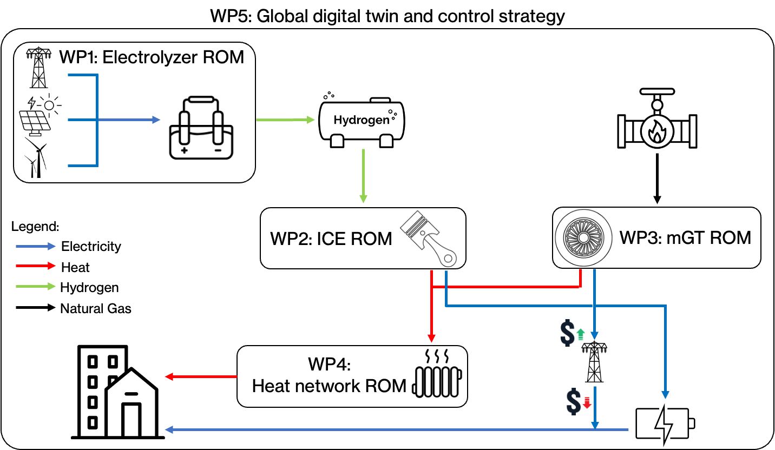

Figure 21: Schematic representation of the hydrogen living lab

In summary, a bespoke MPC algorithm was developed and integrated into the global digital twin of the plant. As schematized in Figure 22, at each time step (τ_{k}), the MPC predicts the system’s future behaviour over a given prediction horizon (τ_{p}) using the plant model. Within this horizon, it optimizes the control actions over a control horizon (τ_{c}≤ τ_{p}) to determine the most cost-effective operating strategy.
The objective of the MPC is to minimize the total operating cost while satisfying all technical and physical constraints (such as electrolyser current limit, hydrogen tank capacity, battery storage limits, ICE and mGT ramp rates, etc) and ensuring that heat and power generation always meets the site’s demand.
Once the optimization is solved, only the first control action is implemented. The horizon then shifts forward by one time step, and the entire process is repeated with updated system measurements, following the receding-horizon principle.

a) | b)
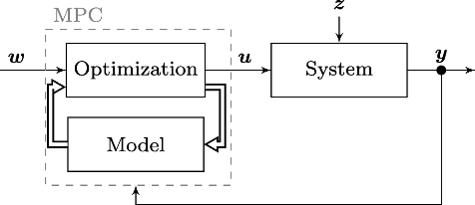 | 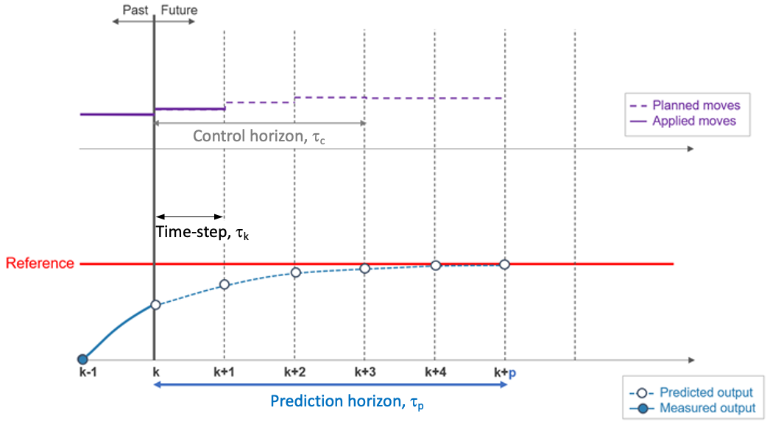
Figure 22: a) Structure of the MPC and b) its functioning

To demonstrate the effectiveness of the MPC framework applied to the global digital twin of the hydrogen plant, a real-case scenario was simulated featuring variable electricity prices and fluctuating heat and power demands. The global digital twin comprises numerous interconnected components, as illustrated in Figure 21. The MPC algorithm supervises the entire system, ensuring that all demands are met while minimizing operating costs. The optimization is performed by minimizing a bespoke cost function subject to physical and technological constraints.
The simulation covered a 1-week period, discretized with a time step of τ_{k}=15 minute. The prediction horizon was set to τ_{p}=24h, allowing the plant operation to be optimized using day-ahead information, namely, forecasts of electricity prices and of heat and power demands. Two different control horizons were evaluated: τ_{c} = 2h and τ_{c} = 12h.
Typically, longer control horizons yield more optimised operation, reducing operating costs, whereas lower τ_{c} decrease computational effort and thus the wall-clock simulation time, but allowing less optimal plant operation.

a) | b)
Figure 23: MPC control algorithm applied to the global digital twin of the hydrogen living lab for two different control horizon: a) τ_{c} =2h and b) τ_{c} =12h.

Results can be discussed as follows. Figure 23 compares the system performance under two MPC control horizons, τ_{c} = 2h (left) and τ_{c} = 12h (right), over a one-week simulation with variable electricity prices and fluctuating energy demands. With τ_{c} = 2h, the controller behaves ‘myopically’, reacting to short-term variations rather than anticipating future trends. This results in frequent switching in hydrogen production and consumption, which leads to strong oscillations in the hydrogen storage level. Conversely, the τ_{c} = 12h case exhibits smoother and more coordinated hydrogen operation, as production is concentrated during low-price periods and consumption during high-price ones, reflecting a more strategic use of storage. A similar pattern is evident in the thermal subsystem: while heat demand remains the same in both cases, the short control horizon produces irregular heat generation and rapid storage cycling, whereas the longer horizon enables the MPC to anticipate demand peaks and manage the thermal storage in a more foresightful way, resulting in smoother heat production and longer, more efficient charge-discharge cycles. In the power subsystem, shorter horizons cause abrupt variations in power dispatch and frequent battery cycling, while the 12 h horizon ensures steadier operation and improved coordination among the power, heat, and hydrogen domains. Overall, extending the control horizon enhances the predictive capability of the MPC, allowing better alignment of production and storage with forecasted conditions. Consequently, the τ_{c} = 12 h configuration achieves a –2.5% reduction in total operating cost (6626 € compared to 6802 € for τ_{c} = 2h), at the expense of a longer simulation time (730 s versus 84 s). Thus, while shorter horizons reduce computational effort, they do so at the cost of less optimal, more myopic plant operation.

Conclusions

This final deliverable lumps all main steps carried out to develop the Physics-Informed Reduced-Order Models (PI-ROMs) of all components of the hydrogen living lab, and their integration into a unified digital twin. On top of this, an advanced Model Predictive Control (MPC) algorithm was also developed for optimizing the plant operation under dynamic conditions, while respecting physical and technological constraints. The main outcomes can be summarised as follows:
- Electrolyser (WP1): A comprehensive multi-physics PEM electrolyser model was developed, coupling electrochemical, thermal, mass-transport, and degradation phenomena. To enable efficient control-oriented simulations, the degradation submodel was replaced with a neural-network surrogate, removing numerical stiffness while maintaining high accuracy. The resulting reduced-order model was successfully integrated into the MPC framework, which was tested under dynamic electricity price scenarios, confirming its ability to optimise electrolyser operation by balancing efficiency and lifetime.
- Internal Combustion Engine (WP2): A two-zone 0D hydrogen engine model was developed and validated against manufacturer data, showing good agreement. Furthermore, to provide the model with additional predictive capability, a symbolic regression–based extension was added. This data-driven approach identified explicit functional relationships between key combustion parameters and operating conditions, enabling the model to predict engine behaviour under variable spark advance and equivalence ratio. The resulting grey-box model holds enhanced accuracy over a wide range of operating conditions, therefore ensuring reliability of prediction, when the ICE is operated by the MPC algorithm.
- Micro-Gas Turbine (WP3): A steady-state reduced-order model of the Turbec T100 was derived from an existing detailed dynamic model. A parameter optimisation procedure was then performed to calibrate the model. Overall, the steady-state mGT ROM achieved high accuracy with reduced computational cost, making it suitable for integration into the global digital twin of the hydrogen living lab.
- District Heating Network (WP4): A dynamic model for the district heating network was developed. The model was able to capture heat transport delays and network inertia, which can be exploited by the MPC as an additional flexibility source to buffer energy price fluctuations and improve overall system efficiency.
- Global Digital Twin and MPC Integration (WP5): All PI-ROMs were coupled into a single integrated digital twin representing the complete hydrogen-based multi-energy system, including hydrogen storage, battery arrays, and thermal storage subsystems. A bespoke MPC controller was developed to coordinate all components, minimising operating costs while satisfying technical and physical constraints. Case studies demonstrated the effectiveness of the overall control framework, yielding cost reduction and smart operation of the plant.
In conclusion, the achieved results demonstrate the feasibility and robustness of the developed physics-informed data-enhanced digital twin, which, once coupled with the MPC-based control algorithm, enabled an effective and real-time optimisation of the global energy system.

